NAME-MAYURI SIDDHU BANDGAR

BATCH NO-7669

**Selenium Project**

**Selenium-**

a)It is an open source and most commonly used tool in automation testing.

b)it supports multiple languages like java,c#,python,Ruby etc.

c)It supports multiple platforms like window,mac,linux etc.

d)It supports multiple browsers like Chrome,Edge,firefox,Safari,Opera etc

e)This tool is used to test web Based application with the help of test Script can be written in java programming language

f)Parallel testing Means at a one time testing on different browser like chrome,firefox,edge etc is done in automation.

g)Third party tools plugin/integrate like TestNG,GitHub,Genkins etc.

Method in Selenium-

* Get method-To launch URL in browser
* Get title method-Return title of webpage
* Get current URL method-return current URL of webpage
* Get pageSource method-Returns HTML code of Webpage

Navigate commond method-

Navigate().to()- It is used to navigate frame one webpage to other webpage and load new URL/webpage to

**PROGRAM CODE-**

**import** org.openqa.selenium.By;

**import** org.openqa.selenium.WebDriver;

**import** org.openqa.selenium.WebElement;

**import** org.openqa.selenium.chrome.ChromeDriver;

**public** **class** seleniumproject2 {

**public** **static** **void** main(String arg[]) **throws** InterruptedException

{

System.*setProperty*("webdriver.chrome.driver","C:\\Users\\Mayuri\\Downloads\\chromedriver.exe");

WebDriver driver=**new** ChromeDriver();

driver.get("https://www.naukri.com/");

driver.manage().window().maximize();

Thread.*sleep*(3000);

driver.findElement(By.*id*("register_Layer")).click();

WebElement a=driver.findElement(By.*id*("name"));

a.sendKeys("mayuri bandgar");

driver.findElement(By.*cssSelector*("#email")).sendKeys("gavademayuri7@gmail.com");

driver.findElement(By.*id*("password")).sendKeys("Mayu@123");

driver.findElement(By.*id*("mobile")).sendKeys("7058517538");

driver.findElement(By.*className*("main-3")).click();

//driver.findElement(By.xpath("/html/body/div/div/div/div[2]/div/div/div[1]/form/div[2]/div[4]/div[2]/div[2]/div[2]/h2")).click();

//driver.findElement(By.id("currentCity")).sendKeys("Pune");

//driver.findElement(By.xpath("//*[@id=\"currentCity\"]")).sendKeys("Pune");

//driver.findElement(By.className("uploadResume resman-btn-primary resman-btn-small")).click();

driver.findElement(By.*xpath*("//*[@id=\"root\"]/div/div/div[2]/div/div/div[1]/form/div[2]/div[5]/div[1]/div[1]/button"));

WebElement chooseFile=driver.findElement(By.*id*("resumeUpload"));

chooseFile.sendKeys("C:\\Users\\Mayuri\\Desktop\\mayubandgar123.docx");

// driver.findElement(By.className("submitbtn resman-btn-primary resman-btn-regular resman-btn-disabled")).click();

//driver.findElement(By.xpath("/html/body/div/div/div/div[2]/div/div/div[1]/form/div[2]/div[7]/button")).click();

// driver.findElement(By.xpath("//td[text()='Register Now']")).click();

driver.findElement(By.*xpath*("Xpath=//*[contains(@type,'submit')]")).click();

//driver.findElement(By.xpath("//*[@id=\"root\"]/div/div/div[2]/div/div/div[1]/form/div[2]/div[7]/button")).click();

}

}

**OUTPUT-**

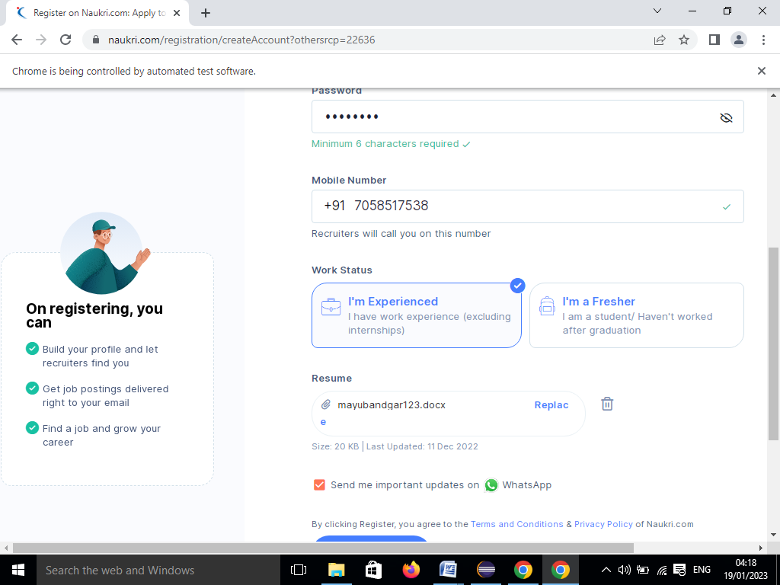

**CUCUMBER**

**INTRODUCTION**

* Install Cucumber
* Write your first Scenario using the Gherkin syntax
* Write your first step definition in Java
* Run Cucumber
* Learn the basic workflow of Behaviour-Driven Development (BDD)

**GHERKIN:** In the cucumber testing, [feature files](https://www.javatpoint.com/feature-file-in-cucumber-testing) are created with the executable test scripts. The language, in which these executable test scripts are written, is known as Gherkin language.

Feature: Each feature file of Cucumber testing starts with a [feature](https://www.javatpoint.com/feature-in-cucumber-testing) keyword. It is a standalone unit or functionality to be tested. For example, login feature, payment transfer feature, registration feature, etc.

**Feature: Login**

**Scenario**: Each feature contains the required number of tests to test the feature. Each test is named as a Scenario. For example, feature login functionality can contain two scenarios, first for a successful login and second for unsuccessful login.

Feature: functionality

Scenario: verify sucessful login

Given user navigates to the website

When user enter valid username

When enter valid password

Then login must be successfully

**CODE CUCUMBER**

**package** cucumber;

**import** org.openqa.selenium.By;

**import** org.openqa.selenium.WebDriver;

**import** org.openqa.selenium.chrome.ChromeDriver;

**import** io.cucumber.java.en.Given;

**import** io.cucumber.java.en.Then;

**import** io.cucumber.java.en.When;

**public** **class** LPF {

WebDriver driver=**new** ChromeDriver();

@Given("user navigates to the website")

**public** **void** user_navigates_to_the_website() {

driver.manage().window().maximize();

driver.get("https://www.instagram.com/");

System.***out***.println("login page is launched");

}

@When("user enter valid username")

**public** **void** user_enter_valid_username() {

driver.findElement(By.*xpath*("//*[@id=\"loginForm\"]/div/div[1]/div/label/input")).sendKeys("mayrub.11");

}

@When("enter valid password")

**public** **void** enter_valid_password() {

driver.findElement(By.*name*("password")).sendKeys("Mayu@123");

driver.findElement(By.*xpath*("/html/body/div[2]/div/div/div/div[1]/div/div/div/div[1]/section/main/article/div[2]/div[1]/div[2]/form/div/div[3]")).click();

}

@Then("login must be successfully")

**public** **void** login_must_be_successfully() {

System.***out***.println("Login page Successfully");

driver.quit();

}

}

**OUTPUT-**

